**Request Letter**

08.03.2020

Trichy

**From:**

M.Patrick Sagayaraj

#4/56, Pillaiyar Kovil Street,

North Paganur (P.O),

Trichy – 620 009

**To:**

The Branch Manager

Karumandapam Branch

Trichy.

**Respected sir,**

Me and my family are most thank full to your good bank for the Help of sanctioning HL of Rs. 25.00 lakhs.

We are sanctioned a HL of Rs. 25.00 lakhs in the month of August 2019. We have still now availed only Rs.22.00 lakhs and the work is yet to be over by one month< (80% of work has been completed yet). The reason for the delay of work completion are that we have met my sister's marriage by September month, and also due to rainy season.

So, with kind and great support we request your good bank to kindly disburse our pending loan amount of Rs.3.00 lakhs. We have paid all our Loan interest without any due. We will complete the work by next month.

The break up for the work completion are as follows:

Wood - 1,15,000/-

Electrical & Plumbing - 2,10,000/-

Tiles - 2,05,000/-

Paint - 1,50,000/-

uPVC - 1,20,000/-

**Total = 8,00,000/-**

With seeing my genuine and loan repayment on timely I request you to kindly sanction of Rs.3.00 lakhs by this week.

Thanking you,

Your’s faithfully

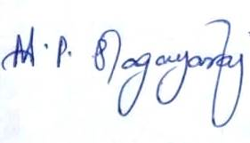

M.Patrick Sagayaraj